7-1 Face Recognition

Jirayu Petchhan, D10907801

For example, and pre-testing tried by face_recognition lib i.e. faces detection part (3ppl.jpg)

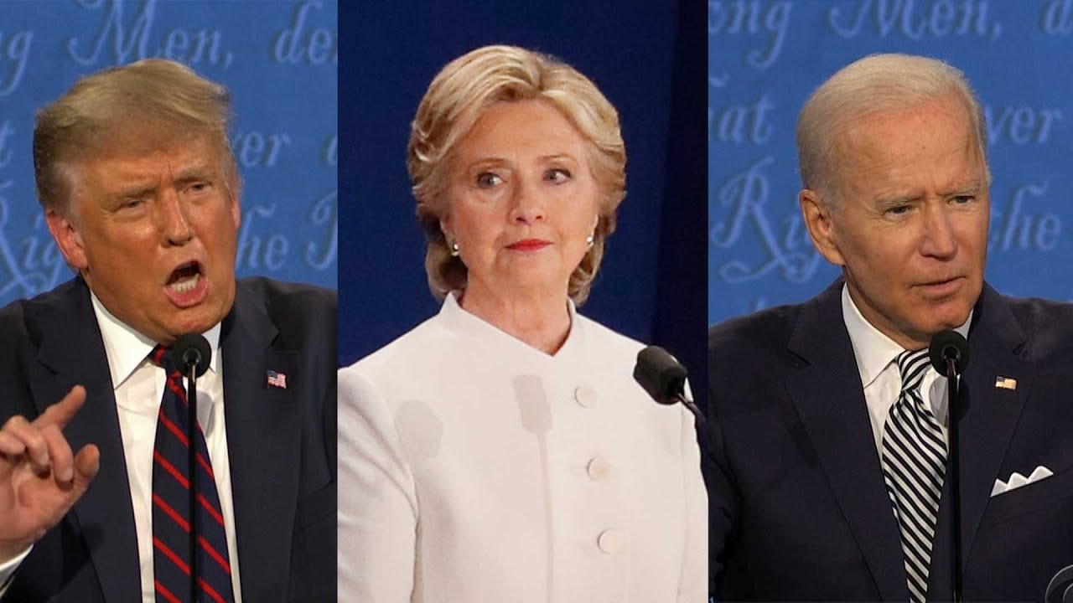

Coding and result

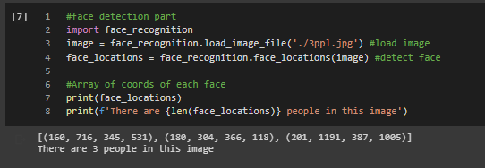

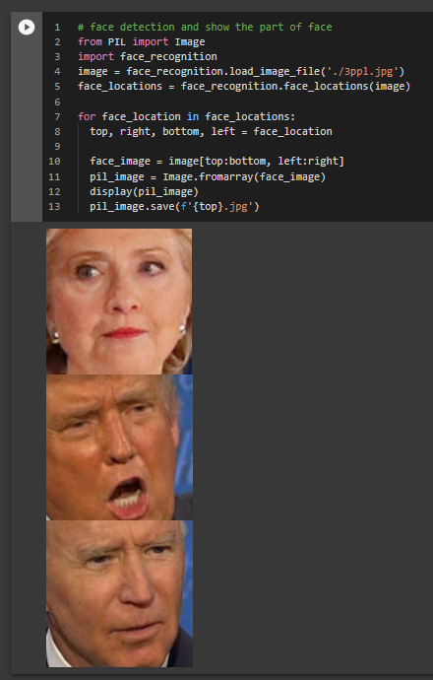

Face identification

|  |  |
| --- | --- |
| Samples | Sample image |
| 1st sample (D. Trump) |  |
| 2nd sample (T. Woods) |  |

Coding

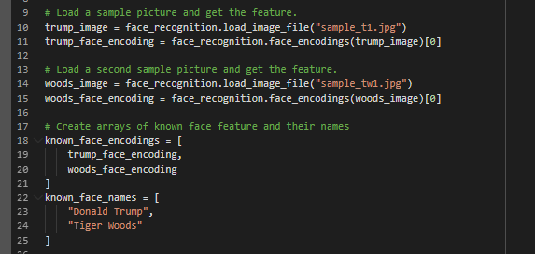

Containing gallery set and changing path

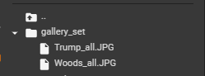

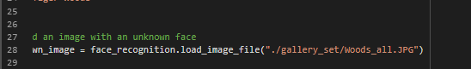

Threshold = 0.35

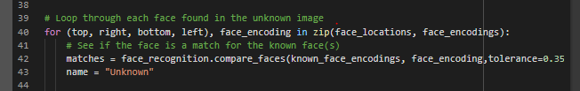

Subject1 (Trump with box)

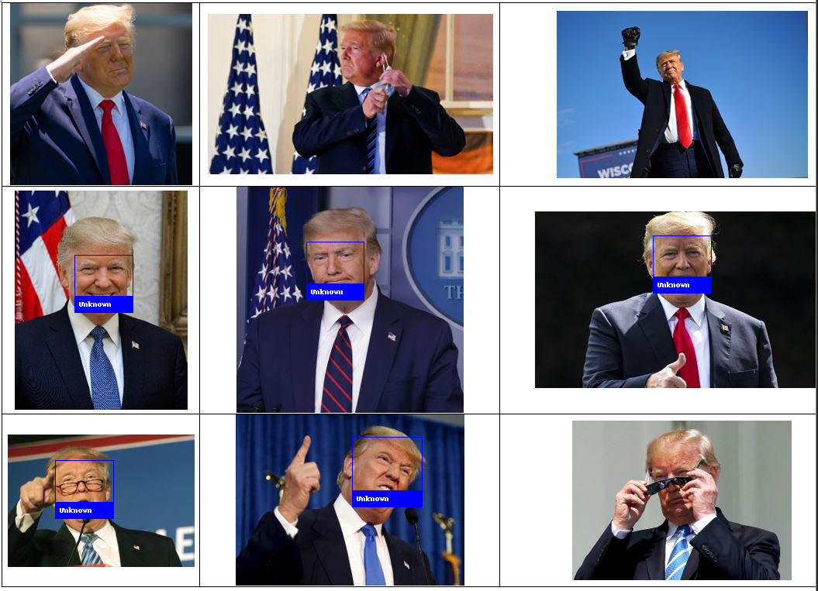

Subject2 (Woods with box)

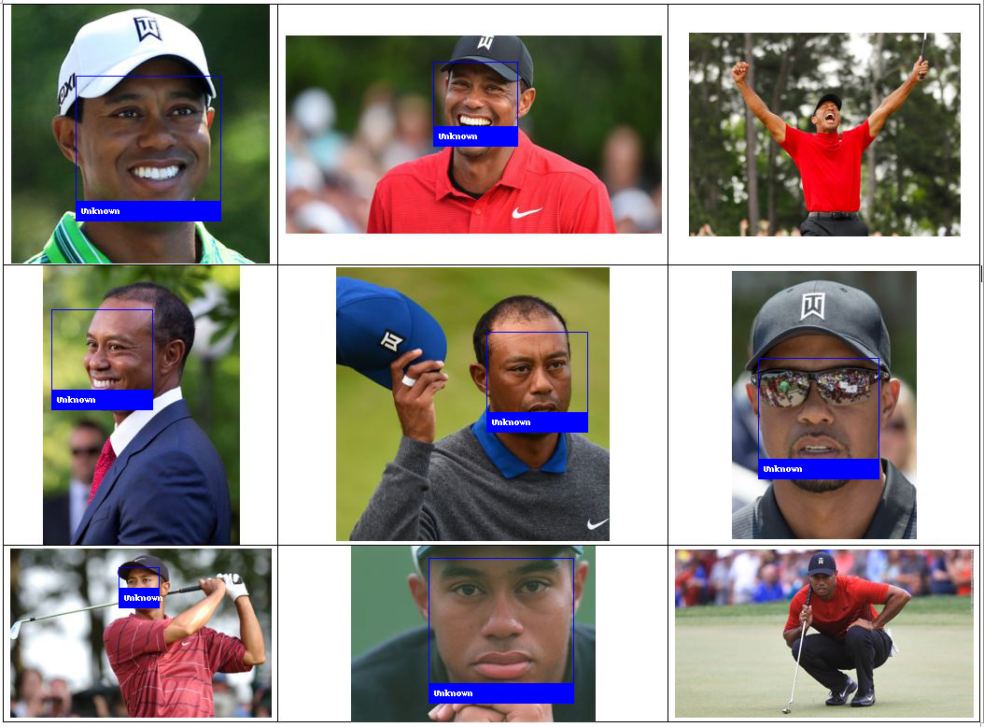

Threshold = 0.65

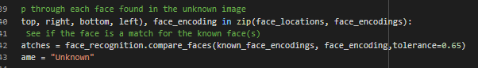

Subject1 (Trump with box)

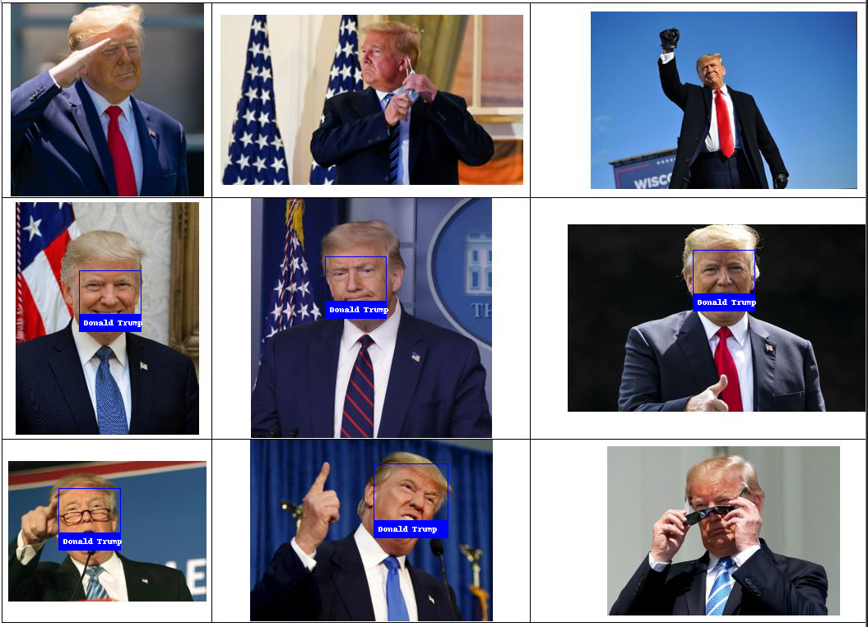

Subject2 (Woods with box)

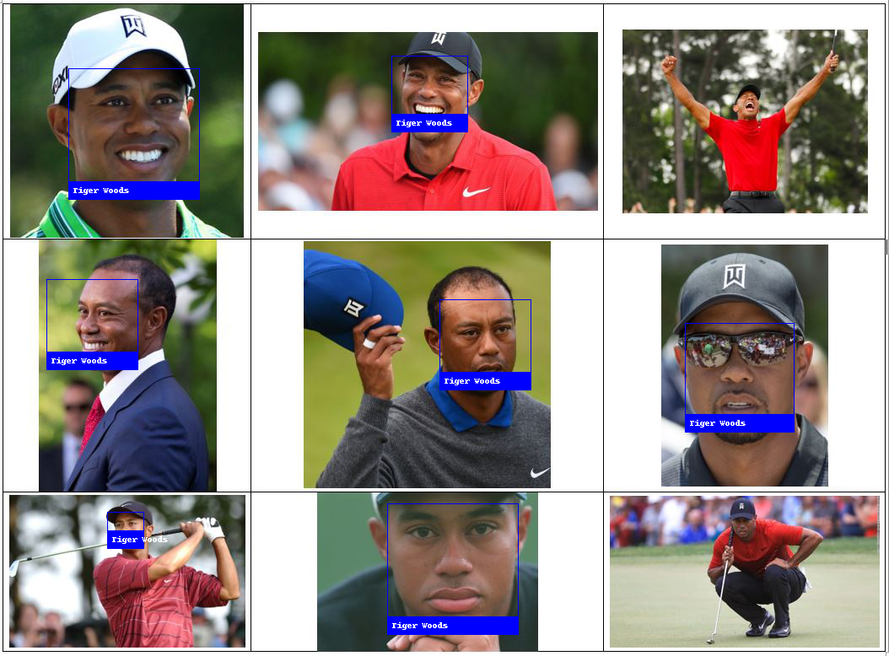

Threshold = 0.95

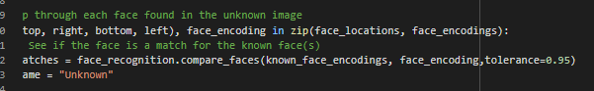

Subject1 (Trump with box)



Subject2 (Woods with box)

